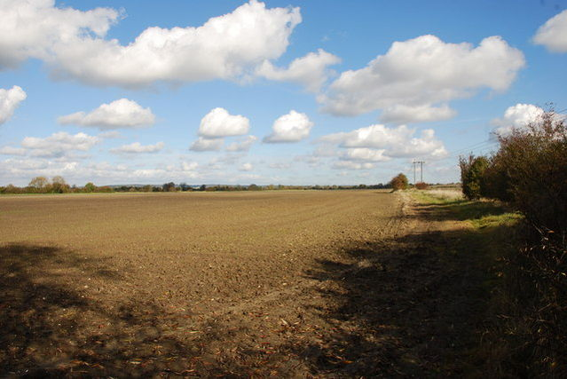
The old Wilts & Berks canal in Drayton Parish The old canal is now infilled between Abingdon and Wantage. Its line is preserved here by the hedgeline and power cables on the right of the photo
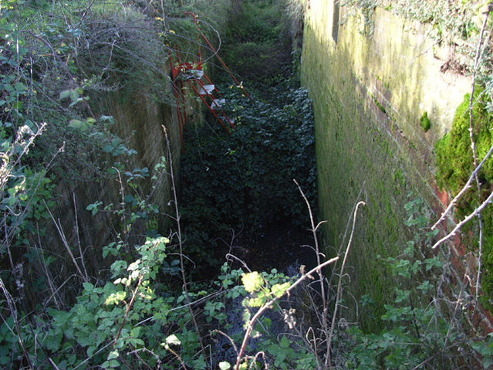
Drayton Lock Former lock on Wilts and Berks Canal. This linked the Kennet and Avon at Semington to the Thames at Abingdon. It was abandoned in 1914. There is a project to reopen the waterway.
- Farmland near Drayton A field of oil-seed rape.
  - England
  - Oxfordshire
  - Farms in Oxfordshire
  - Images from the Geograph British Isles project
  - Images from Geograph needing category review as of 14 December 2010
  - England
  - Oxfordshire
  - Farms in Oxfordshire
  - Images from the Geograph British Isles project
  - Images from Geograph needing category review as of 14 December 2010
- 0 m
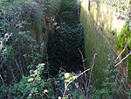
Drayton Lock Former lock on Wilts and Berks Canal. This link…
  - England
  - Oxfordshire
  - Canal locks on the Wilts and Berks Canal
  - Images from the Geograph British Isles project
  - Derelict canal locks
  - Oxfordshire
  - Images from Geograph needing category review as of 14 December 2010
- 30 m
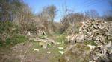
Rubble at the Lock
  - Oxfordshire
- 40 m
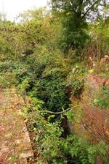
Former lock on the canal
No tags
- 40 m
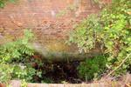
Former lock chamber
No tags
- 45 m
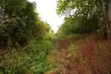
The former Wilts & Berks Canal near Drayton
No tags
- 45 m
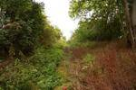
The former Wilts & Berks Canal near Drayton
No tags
- 50 m
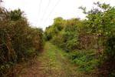
Bridleway by the canal
No tags
- 51 m
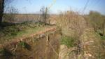
Drayton Lock, Wilts & Berks Canal
  - Oxfordshire
- 51 m
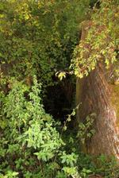
Dry lock chamber near Drayton

SU4594 : Drayton Lock, Wilts & Berks Canal

near to Drayton, Oxfordshire, Great Britain
The Geograph Britain and Ireland project aims to collect geographically representative photographs and information for every square kilometre of Great Britain and Ireland, and you can be part of it.
Read more...
We have at least 4 images that match your query [berks and wilts canal drayton] in the area! View them now
More sizes

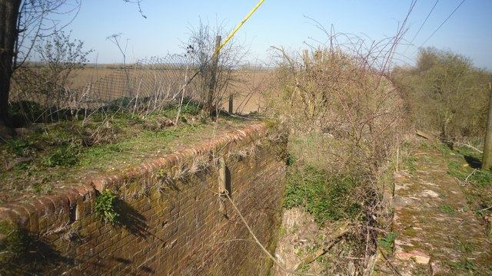
Drayton Lock, Wilts & Berks Canal
This old lock is surprisingly well preserved considering nothing's been through here for nearly 100 years, but it's very overgrown and brambly and almost impossible to get a decent picture of the whole structure. This is the northern end. The canal is filled in beyond. South of here the canal bed is well defined for a while, but isn't in water as the map suggests.
© Copyright Des Blenkinsopp and licensed for reuse under this Creative Commons Licence.
year taken
2012
· Find out how to reuse this image · For example on your webpage, blog, a forum, or Wikipedia. ·
 | Start a discussion on SU4594 |  | Suggest an update to this image |  | Contact the contributor
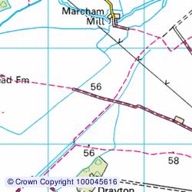

TIP: Click the map for Large scale mapping
Change to interactive Map >
Grid Square
SU4594, 19 images (more nearby)
Photographer
Des Blenkinsopp (find more nearby)
Image classification?
Geograph (Third Visitor for SU4594)
Date Taken
Tuesday, 27 March, 2012 (more nearby)
Submitted
Monday, 2 July, 2012
Geographical Context
Derelict, Disused Canals
Former (from Tags)
canal lock
Subject Location
OSGB36: SU 4525 9401 [10m precision]
WGS84: 51:38.5846N 1:20.8480W
Photographer Location
OSGB36: SU 4525 9401
View Direction
North-northeast (about 22 degrees)

Geograph - photograph every grid square

SU4593 : The former Wilts & Berks Canal near Drayton

near to Drayton, Oxfordshire, Great Britain
The Geograph Britain and Ireland project aims to collect geographically representative photographs and information for every square kilometre of Great Britain and Ireland, and you can be part of it.
Read more...
We have at least 4 images that match your query [berks and wilts canal drayton] in the area! View them now
More sizes

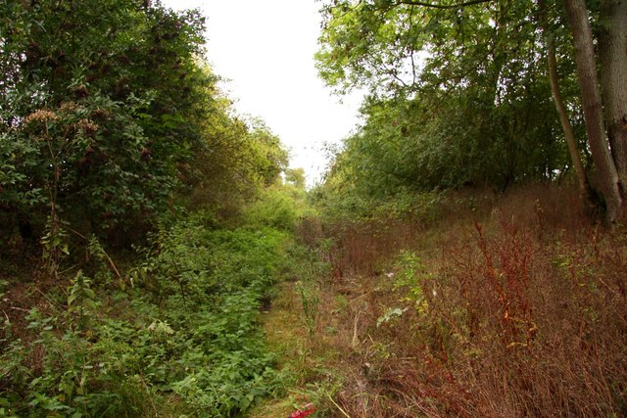
The former Wilts & Berks Canal near Drayton
© Copyright Steve Daniels and licensed for reuse under this Creative Commons Licence.
year taken
2011
· Find out how to reuse this image · For example on your webpage, blog, a forum, or Wikipedia. ·
 | Start a discussion on SU4593 |  | Suggest an update to this image |  | Contact the contributor
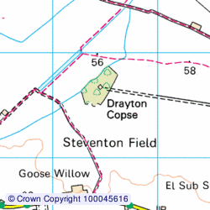
TIP: Click the map for Large scale mapping
Change to interactive Map >
Grid Square
SU4593, 19 images (more nearby)
Photographer
Steve Daniels (find more nearby)
Image classification?
Geograph
Date Taken
Monday, 29 August, 2011 (more nearby)
Submitted
Monday, 5 September, 2011
Geographical Context
Canals
Former (from Tags)
canal
Subject Location
OSGB36: SU 4518 9396 [10m precision]
WGS84: 51:38.5580N 1:20.9090W
Photographer Location
OSGB36: SU 4517 9395
View Direction

Section 46

DRAYTON

COW COMMON LANE TO A34

STATUS
We have permission to work on two sites at present, Steventon Lock and Drayton Lock.
If the proposed Thames Water Reservoir goes ahead, most of this length will be underneath it.
Length:2.86M/4.6kmKm
O.S. Reference:441929 to 475960
Water Level height A.O.D.:
Features:
- Steventon Lock 445934
- Crossing 447936
- Drayton Lock and tailbridge 452936
- Milestone
- Bridge 462951
- A34 crossing (piped)

DESCRIPTION
What Jack Dalby said in 1985"
"Across the road a concrete path leading to a large farm complex covers the canal line past the site of the buried Steventon Lock (445934). Beyond, up to the crossing at 447936, the canal has been levelled. A bridle path alongside the unfilled bed leads to Drayton Lock (452936)under a 10kV power line with a farm crossing at the tail. The power line marks the continued but levelled line as far as 467955 where the bed reappears and can be followed up to the busy Ardington bypass, ....."
The first part of the Canal from Cow Common Lane has been infilled and a concrete farm access road built on top, or possibly to the west of it; further investigation is needed.  This would put the Canal to the right side of the track in the picture.TD> | 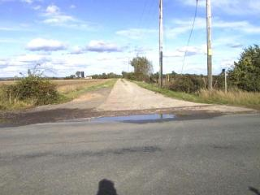
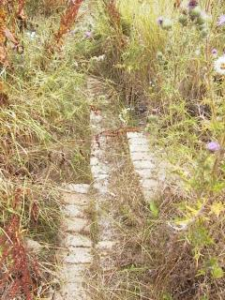 | 100 yards or so from the road is Steventon Lock; during 2004 the site was investigated and the tops of the lock walls exposed.  They aappear to be at almost full height - a pity, because if this line is restored, it will probably have to be relocated to the other side of Cow Common Lane to allow headroom to pass under the road.
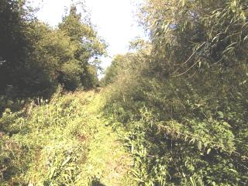 | Past the farm, the concrete road gives way to a muddy farm track up to 453940, where the farm track turns off and a stream crosses.The Canal can be discerned, on the right hand side here, but is comprehensively overgrown.
The Canal now reappears, on a small embankment; a bridle path runs alongside on the east side.  The bed is overgrown but otherwise intact up to Drayton Lock at 452936. | 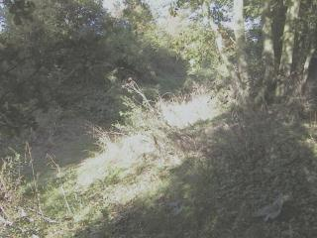
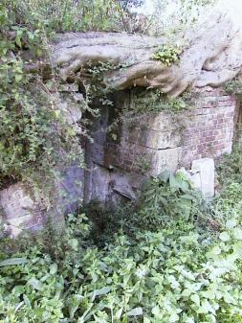 | 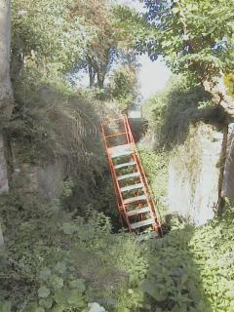
A view of the top offside paddale culvert of Drayton Lock | View from the head of the lock
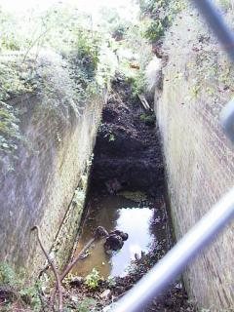 | A view of the tail of the lock, showing progress of clearance.  A considerable length of the invert has been revealed
The tailbridge of Drayton Lock has been destroyed and infilled by a wide farm track.  Beyond the track, part of the lower wing walls are still visible | 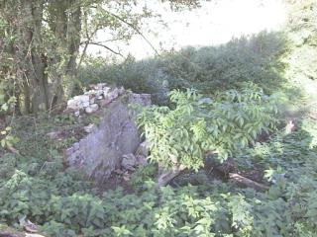
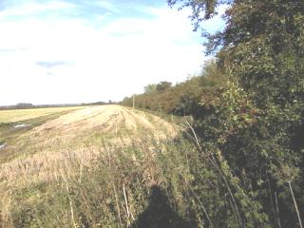 | Beyond here the Canal is reduced to a drainage ditch.  The Canal line is on the right of the field, the vegetation on the right being the towpath hedge.  However, according to the Ove Arup study of the new line to the Thames, the hedgerow here contains many ancient crack willows which provide a habitat for bats and other species, and this may prevent the Canal being restored on its original alignment along here.
The length of canal from Cow Common Lane to around 459947 will be covered by the proposed Thames Water Reservoir, if this gets built. A deviation to the north of the reservoir has been proposed as part of the plan.
The vestigial remains of a bridge may be found at 462951. The Canal is completely infilled at this point.
The bed of the Canal reappears, mostly on an embankment, at 466955 and continues, heavily overgrown, up to the A34.
The final few yards have been infilled. The bridge has totally disappeared, but the A34 is pierced by a pipe on the line of the Canal.

RESTORATION
We have permission to work on Drayton Lock and the bed, approximately 300m above it.
Clearance of Drayton Lock started in 1998 and is proceeding steadily; the presence of high voltage cables across the chamber precludes the use of large machinery.
The invert of the lock has been reached.
A tailbridge is being designed; this will permit the removal of the infill at the tail of the lock and permit connection with the canal line below.

RIGHT OF WAY
A bridle path follows the line of the Canal from Cow Common Lane to 462951, where it forms a T-junction with a crossing bridle path.The branch to the right parallels the Canal, a short distance away, up to the A34.
If you want to walk this section, a course which I highly recommend, stout boots are strongly advised in fine weather , while wellies are absolutely necessary in wet.

WATER SUPPLIES
The landscape on this section is essentially flat, and there are no streams above the level of the Canal. It may be possible to pump water into the Canal in the winter season.

