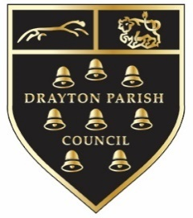
DRAYTON (ABINGDON)
PARISH COUNCIL
www.DraytonPC.org
Drayton (Abingdon) Parish Council

Vacancy for a Part-time Parish Clerk and Responsible Financial Officer (RFO)

Home-based, other than attendance at monthly evening council meetings, the Finance & Personnel Committee meetings, and other occasional visits to Drayton when required.

Hours: 18.5 hours per week, flexible (as arranged with Council)

NJC Scale LC2 (24-28) currently £31,099 - £34,723 pro rata (a starting rate of £16.16 per hour)

The Council offers the Local Government Pension Scheme.

Drayton is a village of some 1,100 dwellings and approx 3,450 residents. The Parish Council operates an allotment site and a cemetery, and has various green spaces and two play areas. There are plans to build additional play and recreation facilities in the near future. The Parish Council has 11 Councillors (4 vacancies) and a precept of £105,280. There are currently two standing committees and four working groups. The Parish Council meets 12 times a year, at 7pm on the second Tuesday of each month.

The Parish Clerk is responsible for the day-to-day management of the councils’ administration and finances, and advises the council on legal, personnel, planning and regulatory matters related to Council business. The Clerk is the line manager for the Deputy Clerk, and the Programme Manager and also manages a variety of contractors.

The successful candidate must be computer literate, competent in maintaining accurate accounts, and have relevant administrative experience. They must be willing to work flexibly.The Council uses the Alpha accounting package and training will be provided if required.

This is a busy parish so the new Clerk should have previous experience in local government, e.g. as an experienced Clerk, a Deputy Clerk for a larger parish or town council, or an administrator in a local authority. They must be able to work successfully with Councillors, staff, residents, Local Authority departments and contractors. Ideally the postholder will be CiLCA qualified, or must be willing to commit to obtaining the qualification within 12 months of appointment.

For further information about the role and an application form please email the clerk at clerk@draytonpc.org

The deadline for receipt of applications is 10th February 2023

Interviews: It is expected that interviews will take place week beginning 20th February

